LAB 3

DHCP – NAT – IPTABLES

Lab Objective
Set up a virtual lab in VMware Workstation with 3 virtual machines:
- Client: Host-Only network only (DHCP client)
- Kali Linux: Two NICs (Host-Only and NAT), acts as DHCP server, NAT gateway, and firewall
- Web Server: Host-Only network only
Configure the Kali Linux machine to:
- Provide DHCP service on Host-Only network
- Provide Internet access (via NAT interface) for Client and Web Server
- Apply iptables rules for basic firewall security
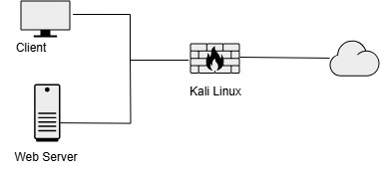
Example IP addresses tables.
Machine | Network Interface | IP Address | Role
Client | Host-Only | DHCP | DHCP Client
Kali Linux | Host-Only | 192.168.100.1 | DHCP Server
Kali Linux | NAT | DHCP (e.g., 10.0.2.15) | NAT Gateway
Web Server | Host-Only | 192.168.100.20 | DHCP Client

PART 1. VMware Network Setup

1. Create Host-Only Network
1. Open VMware Workstation > Edit > Virtual Network Editor
2. Click Add Network... and choose VMnet2 (or any available)
3. Set it to Host-Only
4. Uncheck Use local DHCP service → we will manually assign DHCP via Kali

2. Configure VM Network Interfaces
Kali Linux:
- NIC 1 (Host-Only): Connected to VMnet2
- NIC 2 (NAT): Connected to NAT
Client and Web Server:
- NIC (Host-Only): Connected to VMnet2

PART 2. Step-by-Step Configuration

2.1 On Kali Linux (Gateway)

1. Identify Interfaces
Run:
ip a
Assume:
- eth0 → Host-Only
- eth1 → NAT

2. Set Static IP on Host-Only Interface
Edit interfaces file:
sudo nano /etc/network/interfaces
Add:
auto eth0
iface eth0 inet static
address 192.168.100.1
netmask 255.255.255.0
Restart networking:
sudo systemctl restart networking
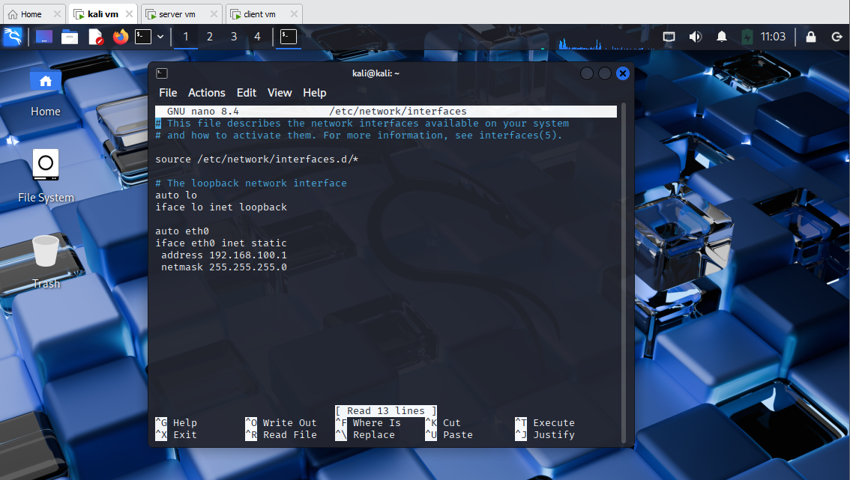

3. Install and Configure DHCP Server
sudo apt update && sudo apt install isc-dhcp-server
Edit config:
sudo nano /etc/dhcp/dhcpd.conf
Add:
subnet 192.168.100.0 netmask 255.255.255.0 {
range 192.168.100.10 192.168.100.50;
option routers 192.168.100.1;
option domain-name-servers 8.8.8.8;
}
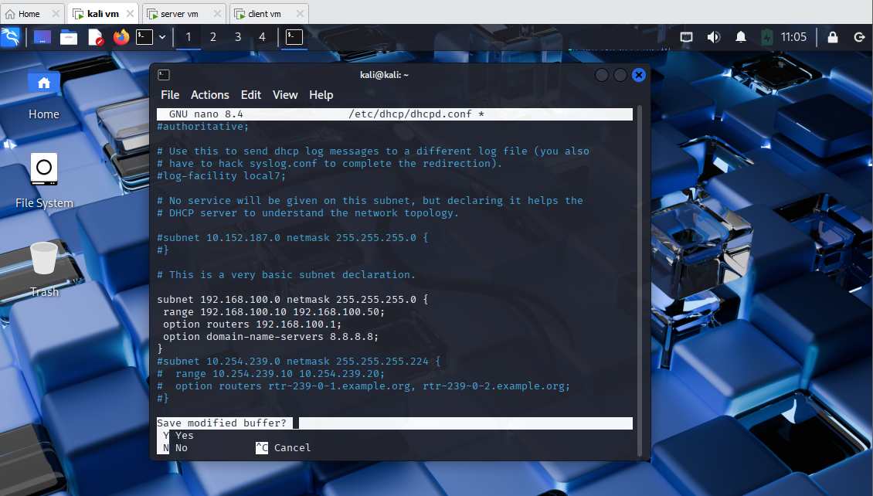
Set interface for DHCP:
sudo nano /etc/default/isc-dhcp-server
Set:
INTERFACESv4="eth0"
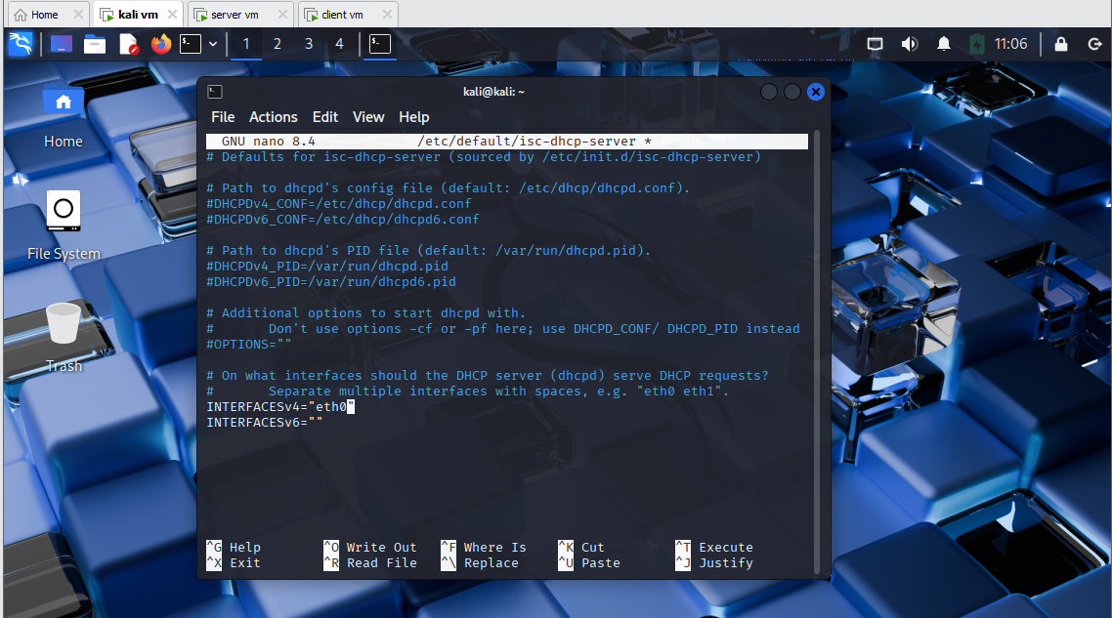
Restart service:
sudo systemctl restart isc-dhcp-server
Check status:
sudo systemctl status isc-dhcp-server
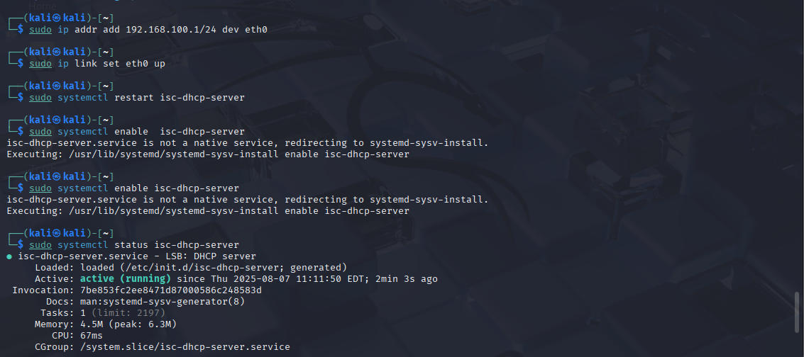
Must assign ip address 192.168.100.1 to interface eth0 before restarting isc-dhcp-server, it is because of if interface eth0 had no ip address, the restart wont work

4. Enable IP Forwarding
Edit file:
sudo nano /etc/sysctl.conf
Uncomment:
net.ipv4.ip_forward=1
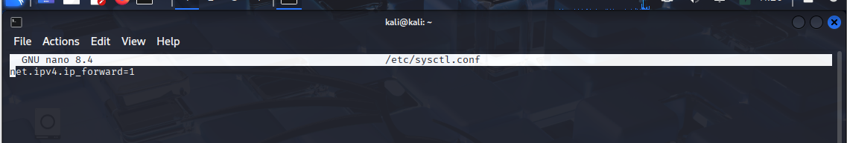
Apply:
sudo sysctl -p
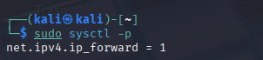

5. Set Up NAT with iptables
sudo iptables -t nat -A POSTROUTING -o eth1 -j MASQUERADE
Make NAT rule persistent:
sudo apt install iptables-persistent
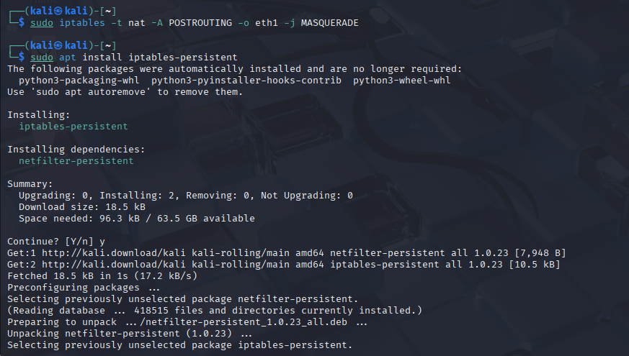
sudo netfilter-persistent save
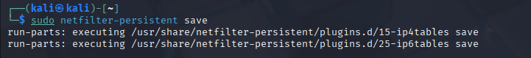
After assigning static address for the gateway, when restarting the networking service, an error should be raised since networking.service and isc-dhcp-server conflicts. So I disabled the networking.service file.
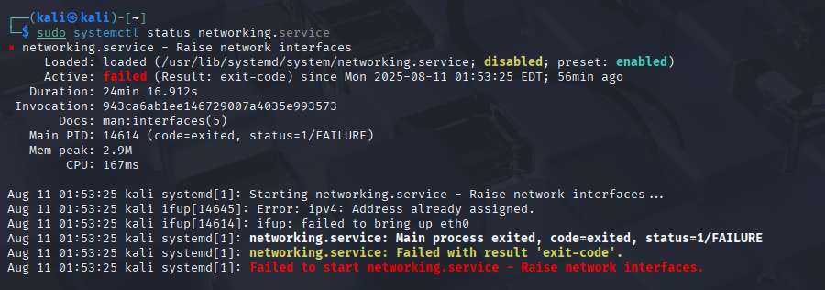

6. Basic Firewall Rules
Create Firewall rule and demontrate the result:
- Only allow the web access from NAT to Host-only
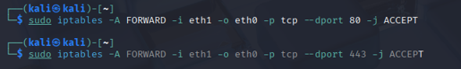
- Prevent the ICMP flood
- Prevent the SSH access from the NAT interface
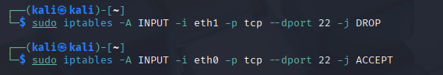

Save the rules: 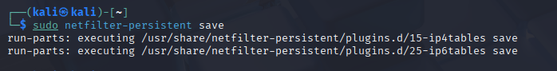

Configured rules:
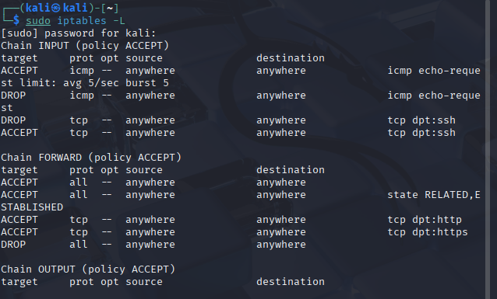

2.2 Client Configuration
- Network: Host-Only (VMnet2)
- DHCP should auto-assign from Kali
- Check IP: ip a
- Test Internet: ping 8.8.8.8
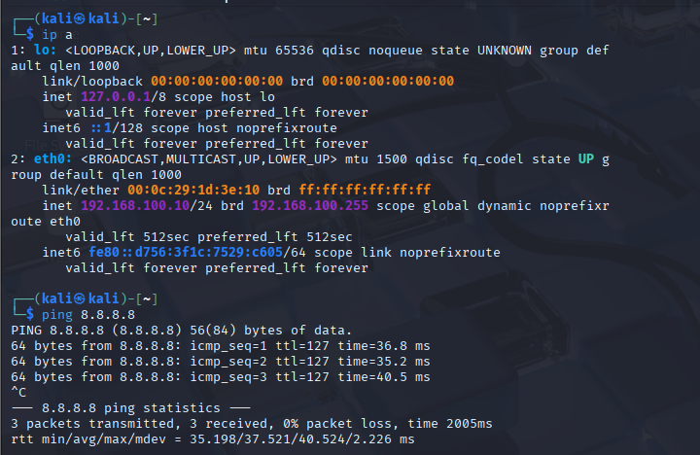

2.3 Web Server Configuration
- Same as Client (Host-Only network)
- Check IP and Internet access
- Create filewall rule and demontrate the result:
- Allow HTTP traffic (port 80) from the Host-Only network
- Allow SSH access (port 22) only from the client.
-This is how the iptables rules should look like after configuring the rules above:
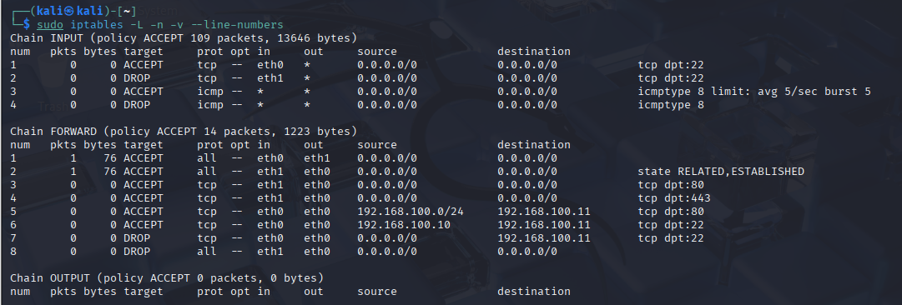

PART 3. Advanced part
Setup Iptables so that the client connect to NAT network can access the Web Server (Using port forwarding)
Configure as below:
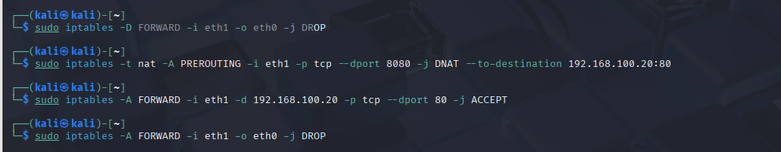
The first command is to delete the drop all rule, so that the next 2 commands would not conflict with it, after configuring the new rules, add the drop rule back to reject every other connections.

